**PHP Assignment**

**MODULE – 2 HTML, CSS, SQL**

**Exercise 1: Try To Create User Details Form.**

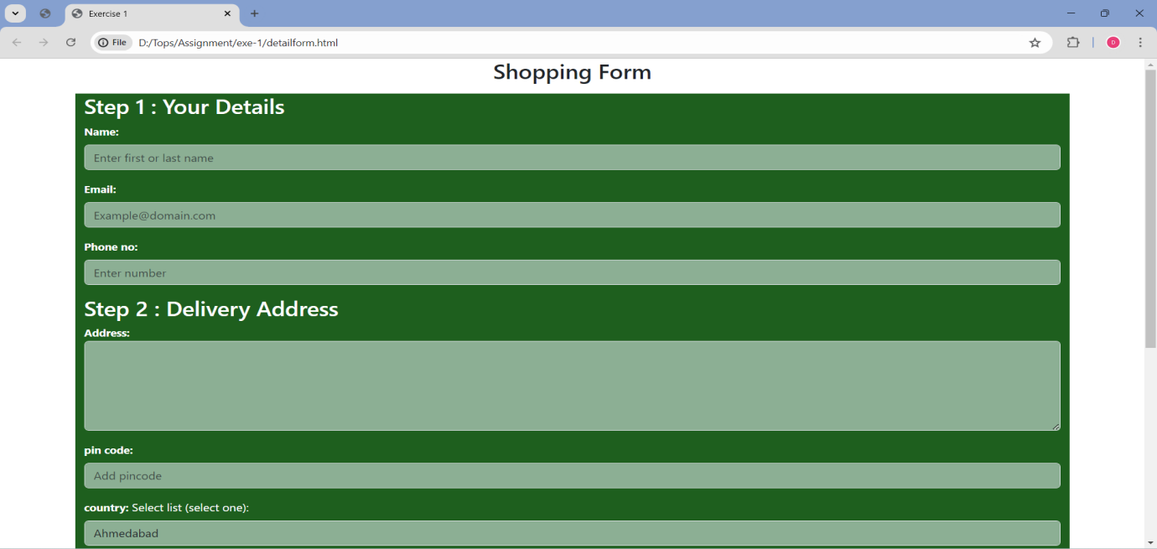

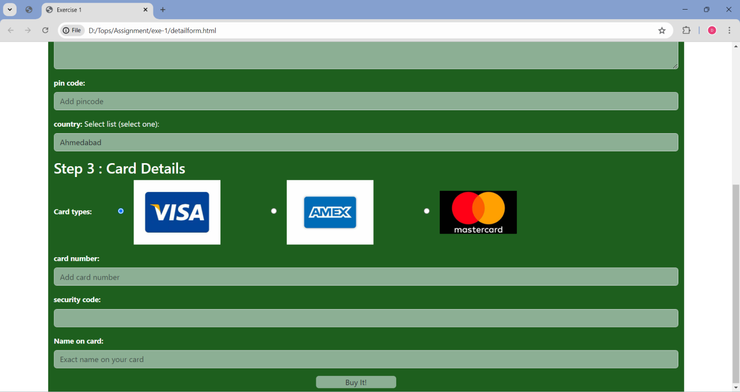

**BOOTSRAP**

**Exercise 1: Create manage Profile:**

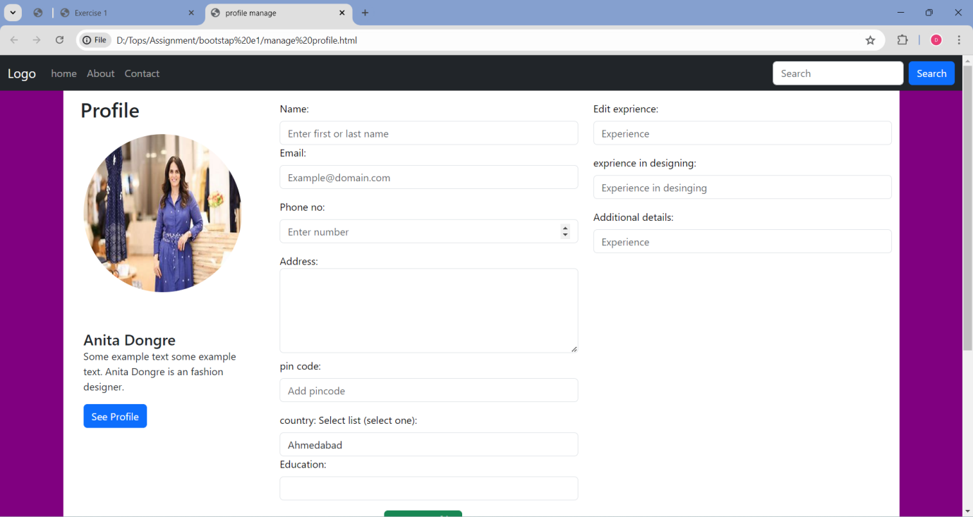

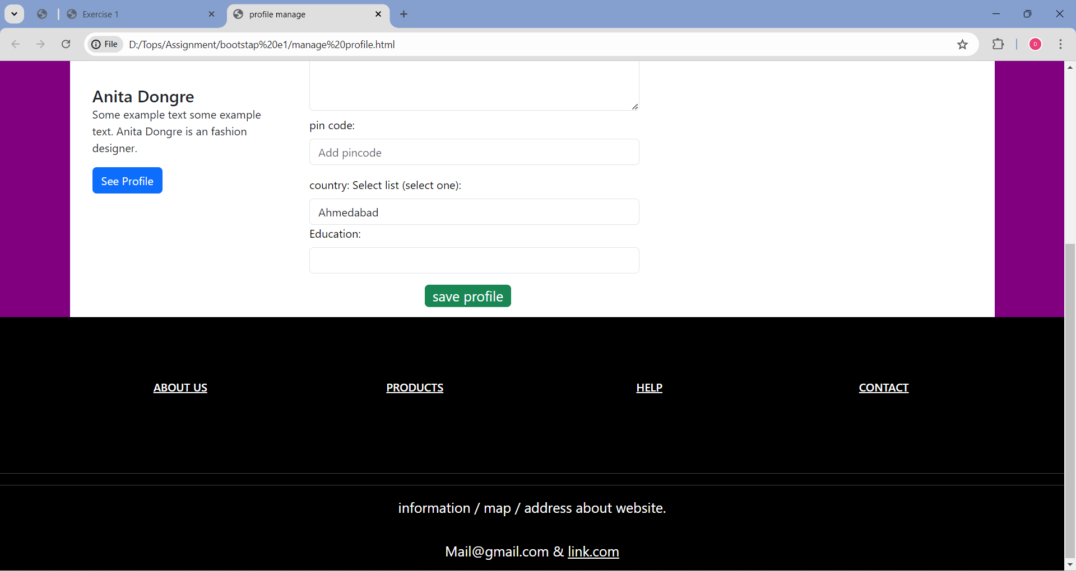

**Exercise 2 : Create ProductListing Page:**

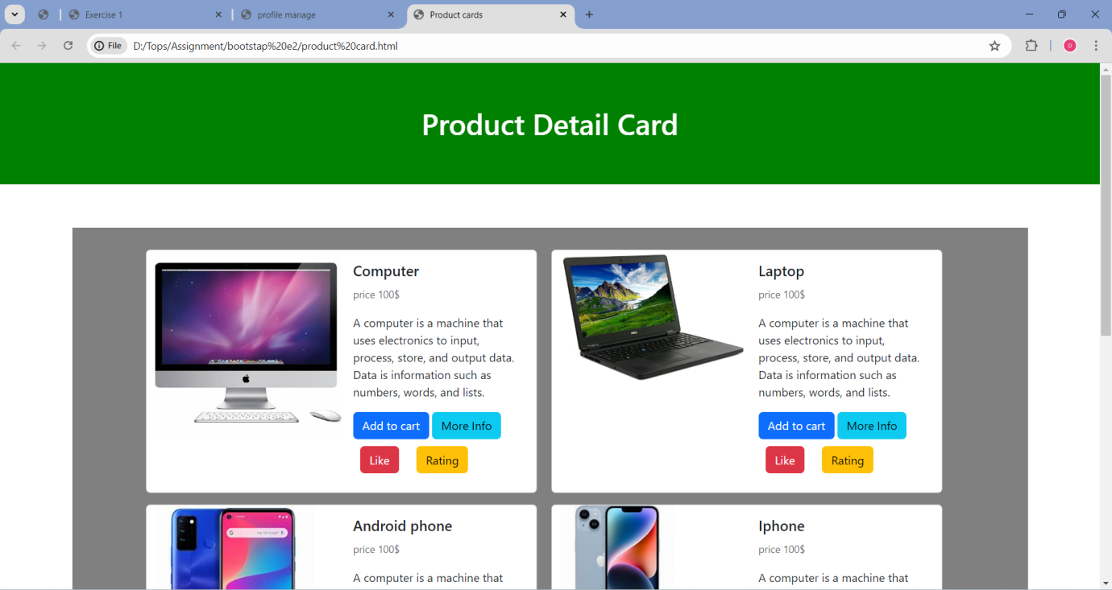

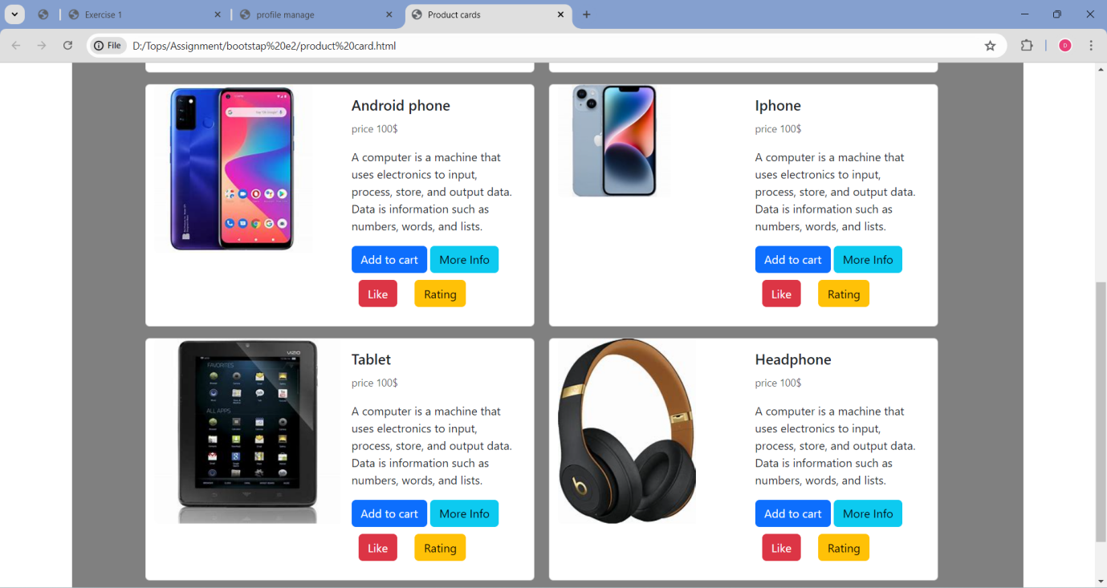

**Topic – SQL Task-1**

**1.Table = employee and incentives**

**a) Get First_Name from employee table using alias name “Employee Name”.**

Answer

SELECT First_Name AS 'Employee Name' FROM employee;

**b) Get FIRST_NAME, Joining year, Joining Month and Joining Date from employee Table.**

Answer

SELECT First_Name,JOINING_DATE FROM employee;

**c) Get all employee details from the employee table order by First Name Ascending And Salary descending?**

SELECT *

FROM employee

ORDER BY FIRST_NAME ASC, SALARY DESC;

**d) Get employee details from employee table whose first name contains „o‟.**

SELECT *

FROM employee

WHERE FIRST_NAME LIKE '%o%';

**e) Get employee details from employee table whose joining month is “January”.**

SELECT * FROM `employee` WHERE JOINING_DATE='2013-01-01'

**f) Get department, total salary with respect to a department from employee table Order By total salary descending.**

SELECT DISTINCT DEPARTMENT, SUM(SALARY) AS Total_Salary

FROM employee

GROUP by DEPARTMENT

ORDER BY Total_Salary DESC;

**g) Get department wise maximum salary from employee table order by salary Ascending?**

SELECT DEPARTMENT, MAX(SALARY)

FROM employee

GROUP BY DEPARTMENT

ORDER BY SALARY ASC;

**h) Select first_name, incentive amount from employee and incentives table for those Employees who have incentives and incentive amount greater than 3000**

SELECT FIRST_NAME, INSENTIVE_AMT

FROM employee

INNER JOIN incentives WHERE INSENTIVE_AMT > '3000';

**i) Select 2nd Highest salary from employee table.**

SELECT MAX(SALARY)

FROM employee

WHERE SALARY < (SELECT MAX(SALARY) FROM employee);

**j) Select first_name, incentive amount from employee and incentives table for all Employees who got incentives using left join.**

SELECT FIRST_NAME, INSENTIVE_AMT

FROM employee

LEFT JOIN incentives

ON employee.FIRST_NAME = incentives.INSENTIVE_AMT;

**k) Create View OF Employee table in which store first name, last name and salary only.**

CREATE VIEW EmployeeInfo AS

SELECT first_name, last_name, salary

FROM Employee;

**l) Create Procedure to find out department wise highest salary.**

SELECT DEPARTMENT, FIRST_NAME, SALARY

FROM employee

WHERE (DEPARTMENT, SALARY) IN (

SELECT DEPARTMENT, MAX(SALARY)

FROM employee

GROUP BY DEPARTMENT

);

**m) Create after Insert trigger on Employee table which insert records in view table.**

CREATE TRIGGER cust_trigger  BEFORE INSERT ON cust FOR EACH ROW

BEGIN

insert into cust_log(FIRST_NAME,LAST_NAME,SALARY,JOING_DATE,DEPARTMENT,Entry_date_time) values (new.FIRST_NAME,new.LAST_NAME,,new.SALARY,new.JOINING_DATE,

new.DEPATMENT,,new.status,now());

END//

**Task-2:**

**SQL**

**TABLE = SALES PERSON,ORDER,CUSTOMER**

**a) All orders for more than $1000.**

SELECT AMT FROM `order` WHERE AMT>1000;

**b) Names and cities of all salespeople in London with commission above 0.10.**

SELECT SNAME,CITY,COMM FROM `sales person` WHERE CITY='LONDON' AND COMM>'O.10';

**c) All salespeople either in Barcelona or in London.**

SELECT * FROM `sales person` WHERE CITY= 'BERCELONA' OR CITY= 'LONDON';

**d) All salespeople with commission between 0.10 and 0.12. (Boundary values should be excluded).**

SELECT * FROM `sales person` WHERE COMM BETWEEN 0.10 AND 0.12;

**e) All customers with NULL values in city column.**

SELECT * FROM `customer` WHERE CITY IS NULL;

**f)All orders taken on Oct 3Rd and Oct 4th 1994.**

SELECT * FROM `order`

WHERE ODE = '1994-10-03' OR ODE = '1994-10-04';

**g) All customers serviced by peel or Motika.**

SELECT * FROM `sales person` WHERE SNO='1001' OR SNO='1004';

**h) All customers whose names begin with a letter from A to B**

SELECT * FROM `customer` WHERE CNAME LIKE 'A%' OR CNAME LIKE 'B%';

**i) All customers excluding those with rating <= 100 unless they are located in Rome.**

SELECT * FROM `customer` WHERE RATING <= '100' OR CITY='ROME';

**j) All orders except those with 0 or NULL value in amt field.**

SELECT * FROM `order` WHERE amt IS NOT NULL ;

**k) Count the number of salespeople currently listing orders in the order table.**

SELECT SNAME, COUNT(`ORDER`.SNO) FROM `sales person`, `order` WHERE `sales person`.SNO = `order`.SNO;